Technical Design Template

Team: | Phantom | ITN: | 132345 |  |  | Solution Design
 |  | Pipeline(s): | SOLUTION_TEST
  Feature Number(s): 306189

Team: 1
ITN: 1
Solution Design 1
Pipeline(s): 1
1 Introduction 1
1.1 Link to Requirements Document 1
1.2 Requirements 1
User Story 1
2 Design Discussion 2
2.1 Use Case 2
2.2 Class Diagrams 2
3 Implementation 3
3.1 Files 3
4 Testing Considerations 4
5 Screenshots 5

Introduction
This is a web-based application used to manage the contacts for a firm. The contacts are stored in a secure location on an internal server and the user is able to log in to the system using their access details.
The user can perform CRUD operations based on the privileges provided to them by the administrator.

Link to Requirements Document
https://jira2.cerner.com/browse/DEVACDMY-5165

Requirements
.

User Story
User Story ID | MH1
Story | Launch the application by signing in
Description | The user is allowed to use the application after the system authenticates the user provided access details.

Design Discussion

Use Case
The use case for this user story can be seen as give below.

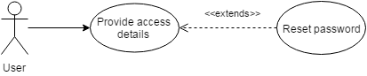
Figure 1 Use Case for user authentication

Class Diagrams

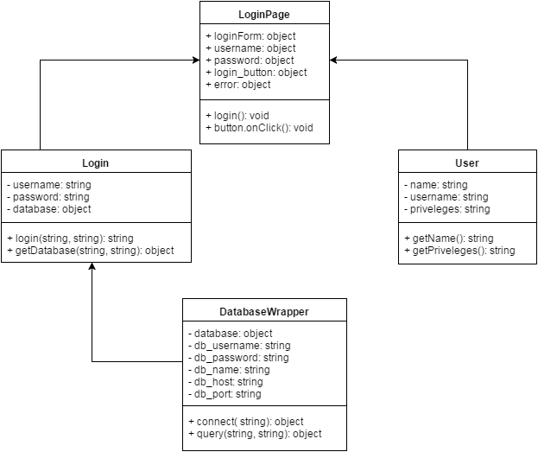
Figure 2 Class Diagram for Login Authentication

Implementation

This user story is to build an authentication portal from where the user gets access to the application. The implementation details are detailed as follows:

- The user is able to enter the username and password into the respective fields on a web form.
- The access credentials are encrypted and sent over to the server-side ‘login.php’ script through an AJAX call using HTTP POST request.
- The server takes the credentials and verifies them from the database by querying the list of registered users and their and login credentials.
- On successful authentication, the session variables are set and the appropriate privileges are assigned to the user. The user is redirected to the dashboard page where the user can add, view, update or delete contacts and their details.
- If authentication is not successful, the user is shown an appropriate error message and asked to re-enter the credentials.

Files

File | login.html
Description | This is the html page that shows the form for entering the username and password. On clicking the login button, it sends an AJAX http request to “login.php” on the server to verify the login details.
Pseudo Code | Javascript(){  DialogForm form = new DialogForm();  form.setupDialogForm();  form.setVisibility( ‘hidden’);  button.onClick() {  form.setVisibility(‘visible’);  }  form.setupValidationScript();  form.setupStylingScript();  }  function login (){  getUsername();  getPassword();  encryptAccessDetails();  sendAJAXRequestForAuthetication();  receiveLoginResponse();  }
Passive (Yes/No) | No

File | css/style.css
Description | This is the css file for the “login.html”. It describes the styles for each and every html element present in the login page.
Passive (Yes/No) | No

File | login.php
Description | This is the php script that receives the encrypted username and password through the HTTP POST method. It connects to the MySQL database and matches the credentials from the database. On unsuccessful authentication, it sends an appropriate error message to the user.
Pseudo Code | function login(){  if ( isSet($_POST )) {  getUsername();  getPassword();  connectToDatabase();  PDO database = new PDOObject();  database = getPDOinstanceOfDatabse();  SQL query = “form sql query”;  database.fetchResults();  if ( numResults == 0){  message( ‘Wrong username/password’ );  }elseif (numResults == 1){  Message( ‘Welcome, ’ + NameOfUser );  }else{  Message( ‘More than one user exists with the same username’)  }  }  }
Passive (Yes/No) | Yes

Testing Considerations
#Test Cases | Test Steps | Expected Results
TC 1 | - Enter correct username and password.  - Click on the Login button | The user session variables are set and is redirected to the home page.
TC 2 | - Enter incorrect username and password  - Click on the login button | The user is shown an error message saying “Incorrect username/password”
TC 3 | - Shutdown the MySQL server  - Enter any username/password  - Click on the login button | The user should be displayed an error message saying “We cannot process your request”

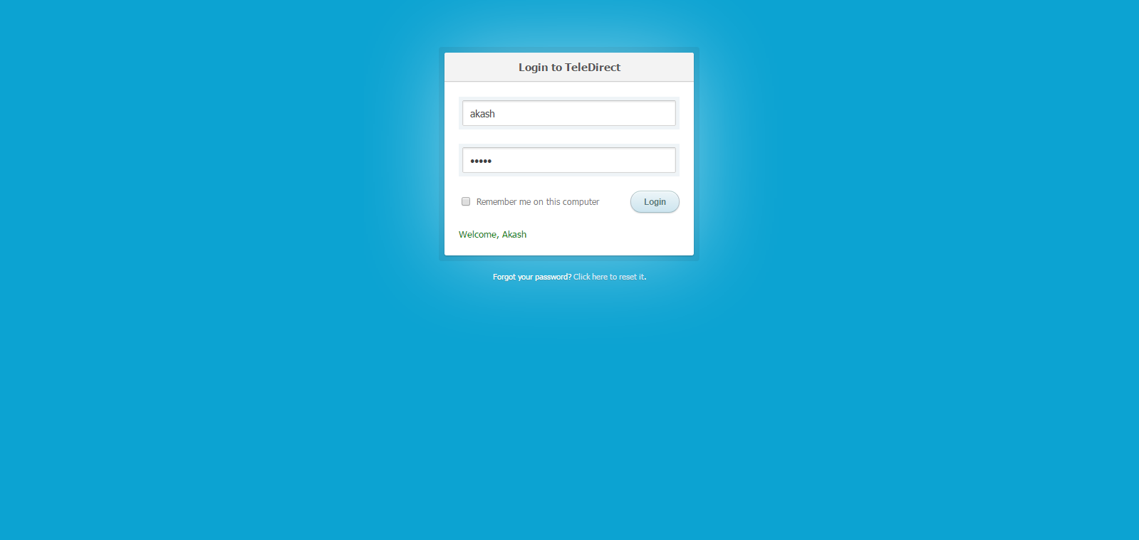
Screenshots
Figure 3 Login Success

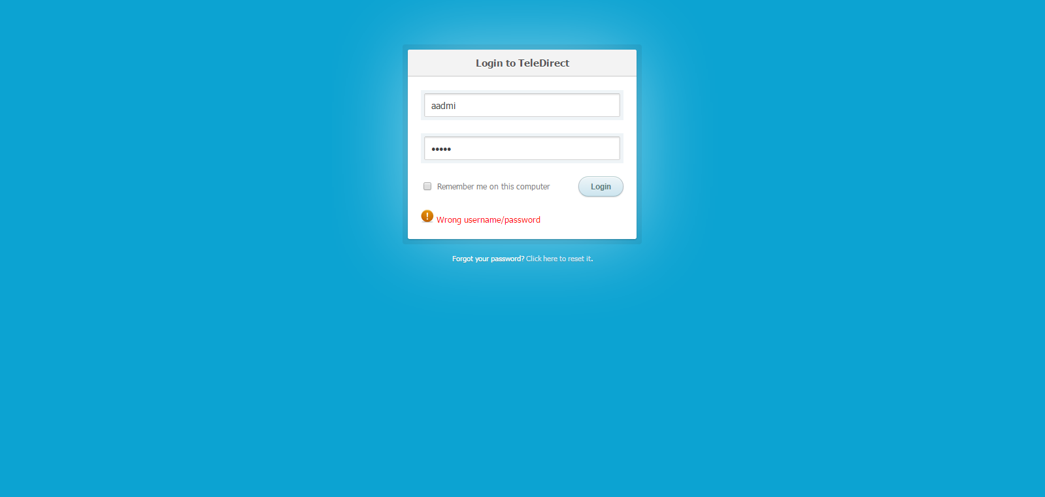
Figure 4 Login Failure

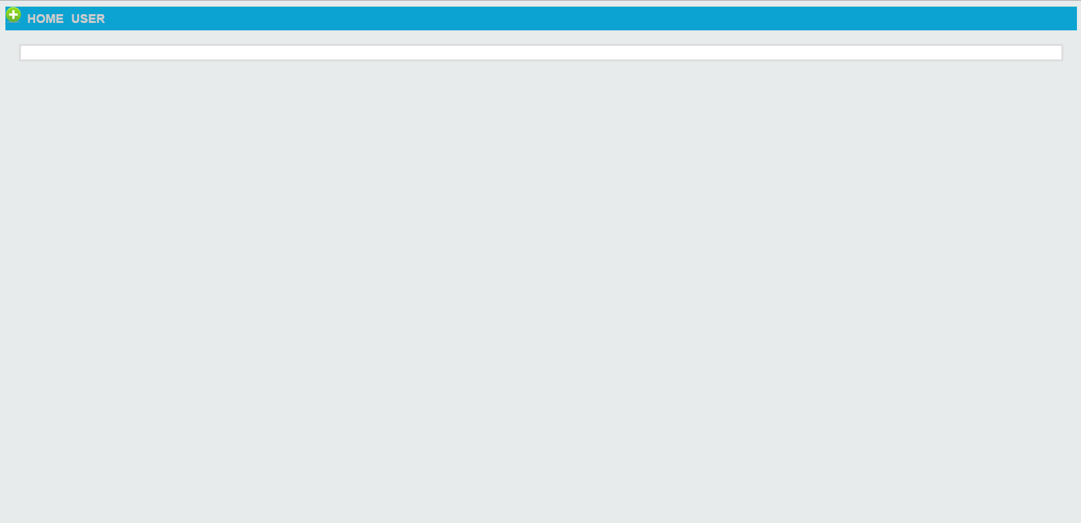
Figure 5 Home Page

